Helpless
Tune down the strings one and a half step:
Db Gb B E Ab Db
Intro: A G F#m7 Em7 (two times)
Em
I don't know why,
You bring my sense alive,
You know you look so foxy wise
You turn my head around
You know the talk's around town
You do a funky rumba
You make an old man stop
You make a young man wonder;
Come on and love me
Come on and love me
Until I'm helpless
Come on and love me
Until I'm
G F# F E G F# F E
Helpless helpless Helpless helpless
Em
Makin' love like a skin cat crawlin' across the highway
I don't know why
You bring my sense alive
Come on and love me untill I'm helpless
Come on and love me untill I'm
G F# F E G F# F E
Helpless helpless Helpless helpless
Em
Makin' love like a skin cat crawlin' 'cross the highway
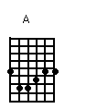 | 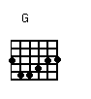 | 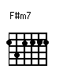 | 