Make It Right
Tuning: two steps down: C F Bb Eb G C
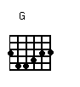
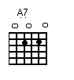
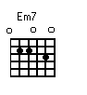
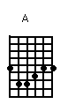
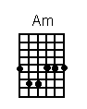
Intro Em Am
Em Am
I'm fitting out I'm fitting in
Em Am
And those diesel rigs aw they're rammin' by
Em Am Em Am
But I ain't blue, now if I go lame I just flag a ride
Em A Em7 A7 Em A
I'm lookin' out for a street corner girl
Em7 A7 Em7 A7
I'm lookin' out For a street corner girl
G F
And she's gonna beat me whip me spank me aw make it right again,
G F
Trying a little trick honey Aw that you never used before
G F
I wanna be your victim your sweet little victim of love
G F
Come on and beat me whip me spank me mama make it right again
Em Am
Ah make it right
Em Am
It's been wrong too long
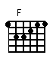
Em Am Em
oh, Johhny Dreams you and my white queen been rolling again
Am Em
Well the talk around town is she might be burned out
Am Em
But I know by midnight she gonna burn you down
Am
Yeah, she gonna burn you down
Em A Em7 A7 Em A
I'm lookin' out in the wings for a street corner girl
Em7 A7 Em7 A7
I'm lookin' out for a street corner girl
G F
And she's gonna beat me whip me spank me aw make it right again
G F
Trying a little trick honey you never used before
G F
I wanna be your victim, your sweet little victim of love
G F
Come on and beat me spank me whip me mama make it right again
Em Am
